Setting Target Approaches for Fiscal Year 2017 Performance Measures

FATALITY 2

5-Year Rolling Average Trend - Fatality 2

3-Year Rolling Average Trend - Fatality 2

10 Years Actual Data Trend – Fatality 3

Alternate Baseline – Fatality 3

Simple Average for 5 Years Actual Data - Fatality 4

5 Years Actual Data Trend- Fatality 4

Simple Average for 5-Year Rolling Averages – Fatality 5

Simple Average for 5-Year Rolling Averages (preliminary 2015 included) – Fatality 5

FATALITY RATE 6

5-Year Rolling Average Trend – Fatality Rate 6

3-Year Rolling Average Trend – Fatality Rate 6

10 Years Actual Data Trend – Fatality Rate 7

Alternate Baseline – Fatality Rate 7

Simple Average for 5 Years Actual Data – Fatality Rate 7

5 Years Actual Data Trend– Fatality Rate 8

Simple Average for 5-Year Rolling Averages – Fatality Rate 8

Simple Average for 5-Year Rolling Averages (preliminary 2015 included) – Fatality Rate 9

SERIOUS INJURY 10

5-Year Rolling Average Trend – Serious Injury 10

3-Year Rolling Average Trend – Serious Injury 10

10 Years Actual Data Trend – Serious Injury 11

Alternate Baseline – Serious Injury 11

Simple Average for 5 Years Actual Data – Serious Injury 11

5 Years Actual Data Trend– Serious Injury 12

Simple Average for 5-Year Rolling Averages – Serious Injury 12

SERIOUS INJURY RATE 13

5-Year Rolling Average Trend – Serious Injury Rate 13

3-Year Rolling Average Trend – Serious Injury Rate 13

10 Years Actual Data Trend – Serious Injury Rate 14

Alternate Baseline – Serious Injury Rate 14

Simple Average for 5 Years Actual Data – Serious Injury Rate 14

5 Years Actual Data Trend– Serious Injury Rate 15

Simple Average for 5-Year Rolling Averages – Serious Injury Rate 15

Non-motorized Fatalities and Serious Injuries 16

Simple Average for 5 Years Actual Data – Non-Motorized Fatalities and Serious Injuries 16

5 Years Actual Data Trend – Non-Motorized Fatalities and Serious Injuries 16

# FATALITY

Initially, to set a target for 2017 a rolling (moving) average method was used to create a scatter plot and through a linear regression analysis, predict the value for the target year. Also, statistical confidence levels for the predictions were also calculated based on a 70% confidence level and the target values were chosen according to the predicted values and their lower/upper bounds.

## 5-Year Rolling Average Trend - Fatality

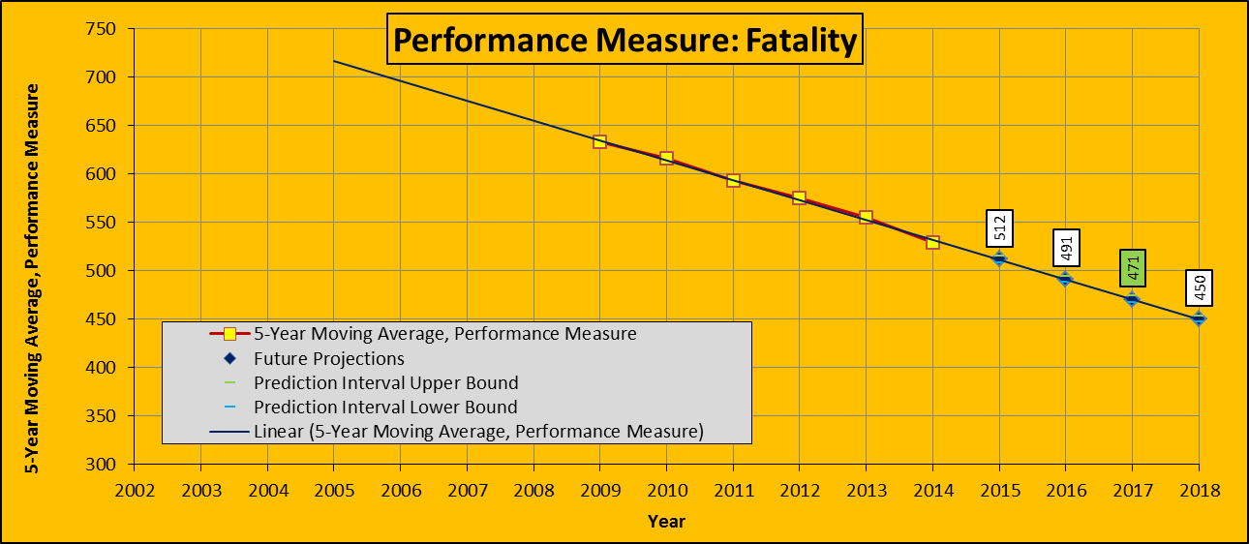

## 3-Year Rolling Average Trend - Fatality

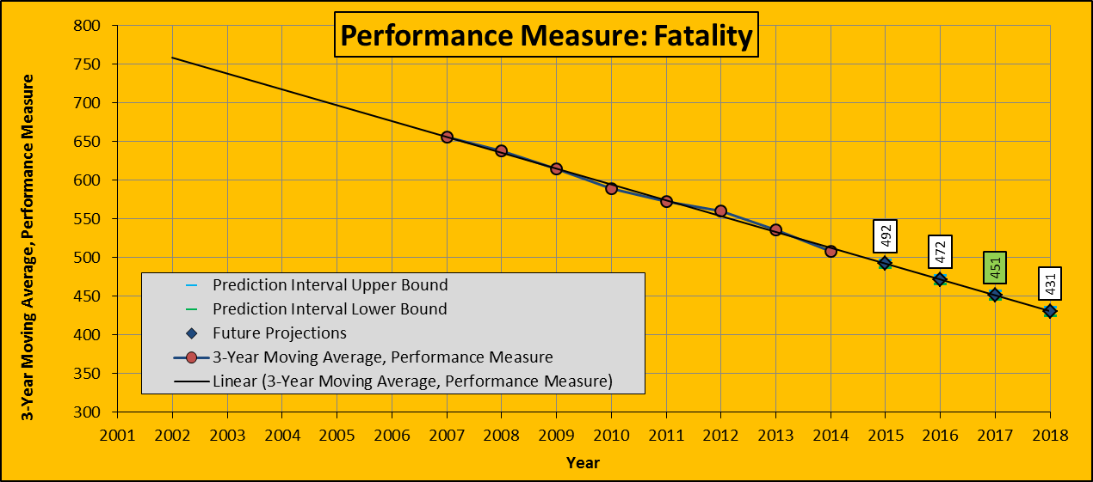

## 10 Years Actual Data Trend – Fatality

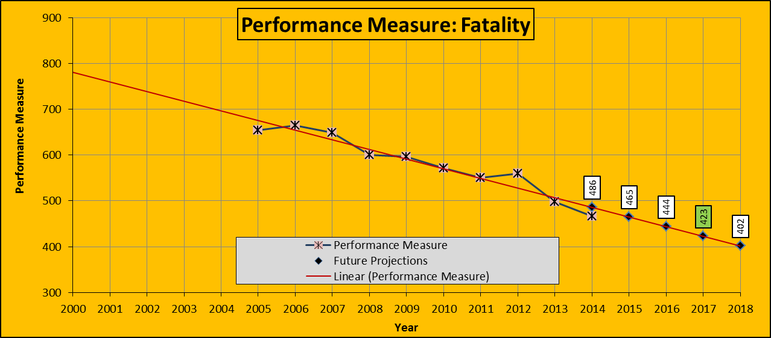

Another method that was used to find a potential target value was the alternate baseline method which resulted in another value that could possibly be used for this purpose.

## Alternate Baseline – Fatality





Then the new FHWA rule for setting performance measure targets was published in which the confidence intervals of the predictions were no longer a required part of the process and any sound statistical method could be utilized to set target values for the performance measures. FHWA also provided an example of how to find and set a target value for a performance measure. This was based on a simple average of the most recent available data as the future target value.

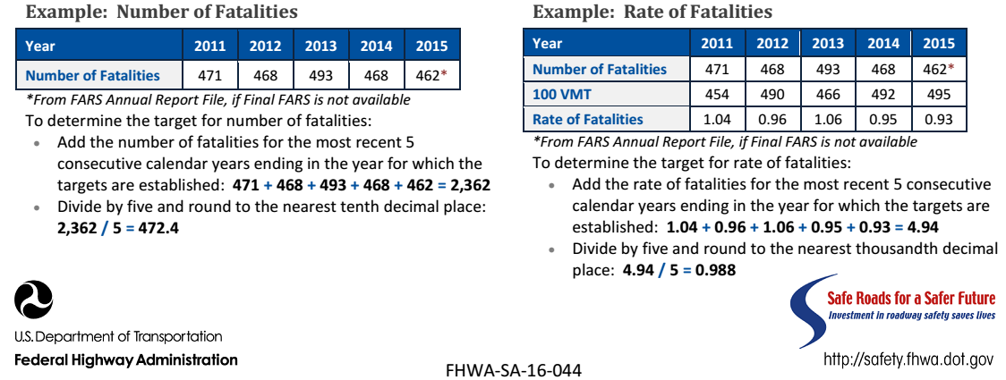

## Simple Average for 5 Years Actual Data - Fatality

Using this approach for Arkansas results in an average value of 521

|  |  |  |  |  |  |  |
| --- | --- | --- | --- | --- | --- | --- |
| **Year** | **2011** | **2012** | **2013** | **2014** | **2015** | **Average** |
| **Number of Fatalities** | **551** | **560** | **498** | **466** | **531** | **521** |

Currently the trend of crash occurrences is growing due to the increase in wet-weather, lower gas prices, more work zones due to rehabilitation of interstate system etc. This trend makes this average value an unrealistic target and low based on the current trends.

## 5 Years Actual Data Trend- Fatality

If we use the same increasing trend in fatalities (2014 to 2015), and estimate a value for 2016 (which so far happens to be the case), we will have a potential number of fatalities of 605. Using this value in a simple trend linear regression will predict the number of fatalities for 2017 to be 569. This value seems to be a more reasonable target for fatalities of 2017.

|  |  |  |  |  |  |  |  |  |
| --- | --- | --- | --- | --- | --- | --- | --- | --- |
| **Year** | **2012** | **2013** | **2014** | **2015** | **2016** | **Average** | **Simple Increase 2017** | **Trend Prediction 2017** |
| **Number of Fatalities** | **560** | **498** | **466** | **531** | **605** | **532** | **689** | **569** |

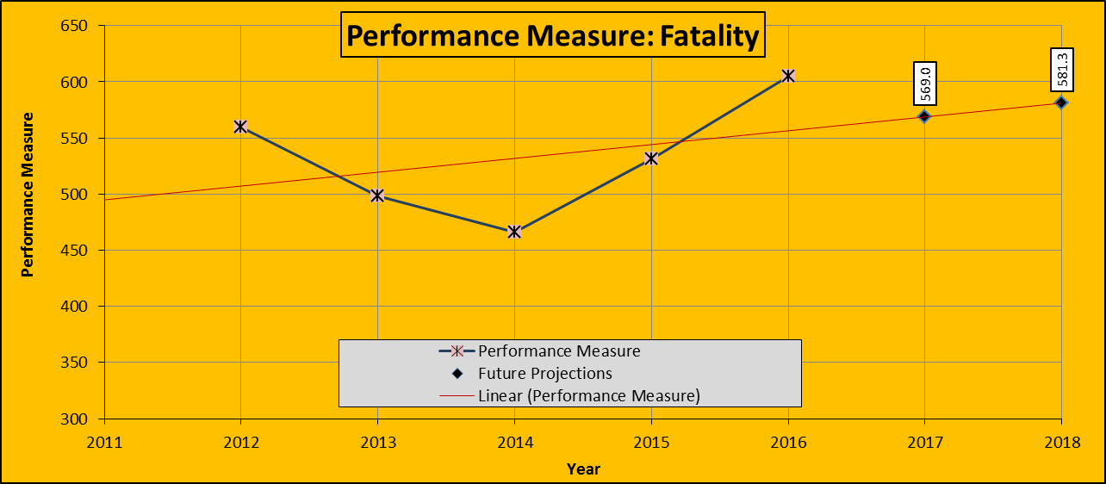

Then it was decided to use the 5 rolling average values of the most recent data available according to FARS, which is 2014, and set the 2017 target value as the average of those rolling average values. For example, doing so will result in a target fatality value of 573.9 for 2017.

## Simple Average for 5-Year Rolling Averages – Fatality

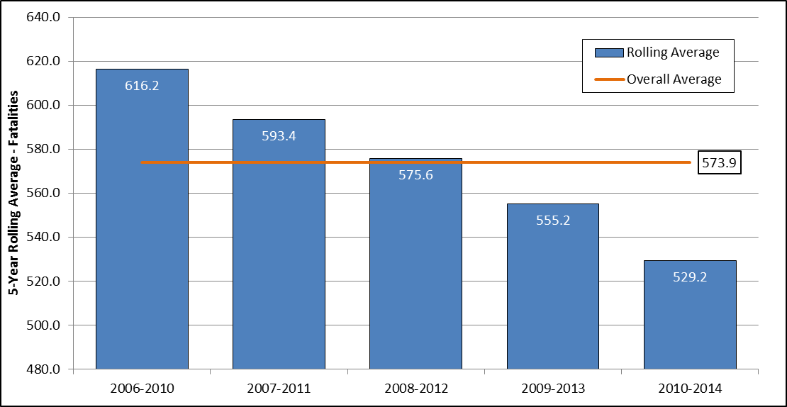

After a meeting with the highway police department and FHWA and MPO representatives, it was decided to use the preliminary data for the 2015 as well to set the targets according to the simple average of 5-year rolling average method (the latest method illustrated above).

## Simple Average for 5-Year Rolling Averages (preliminary 2015 included) – Fatality

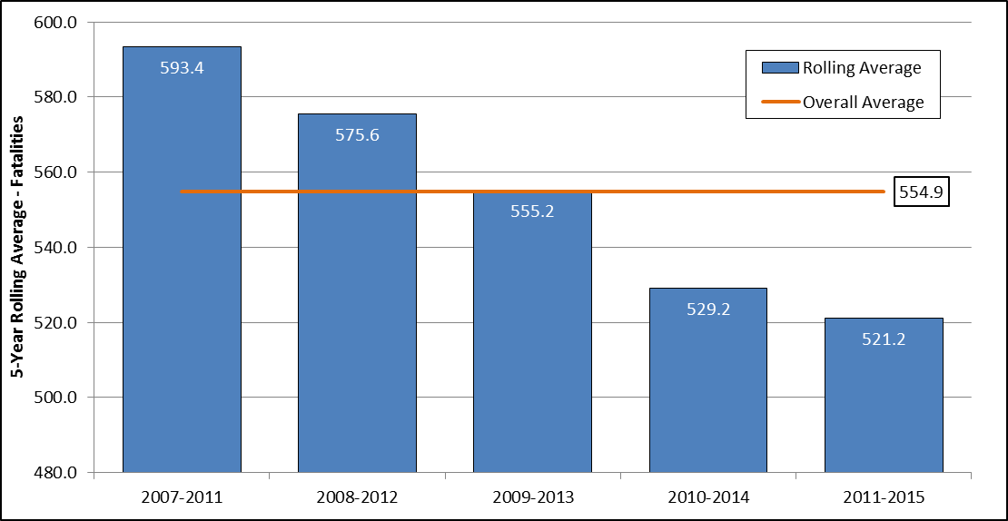

# FATALITY RATE

## 5-Year Rolling Average Trend – Fatality Rate

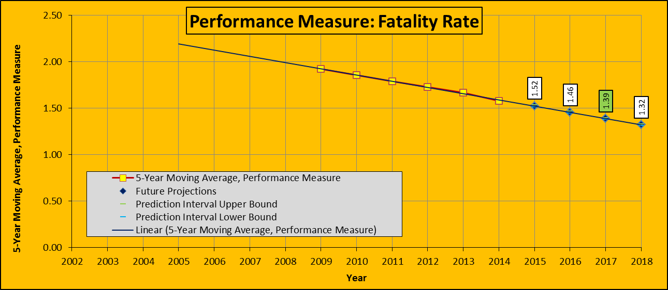

## 3-Year Rolling Average Trend – Fatality Rate

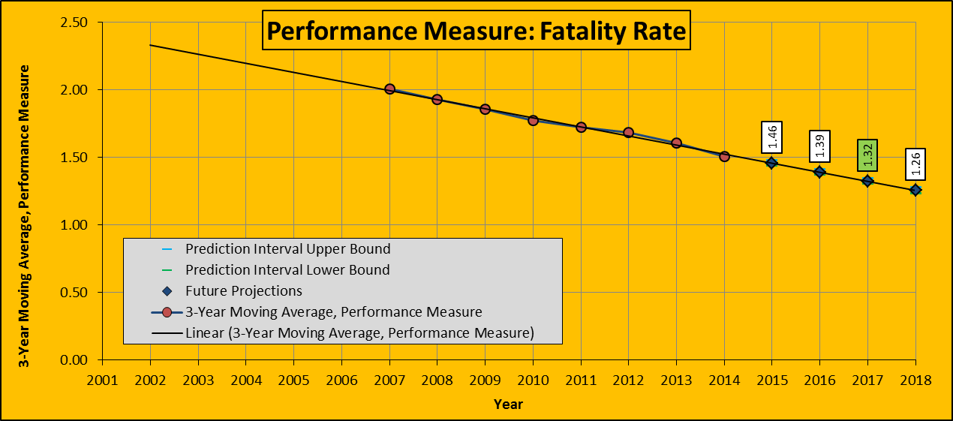

## 10 Years Actual Data Trend – Fatality Rate

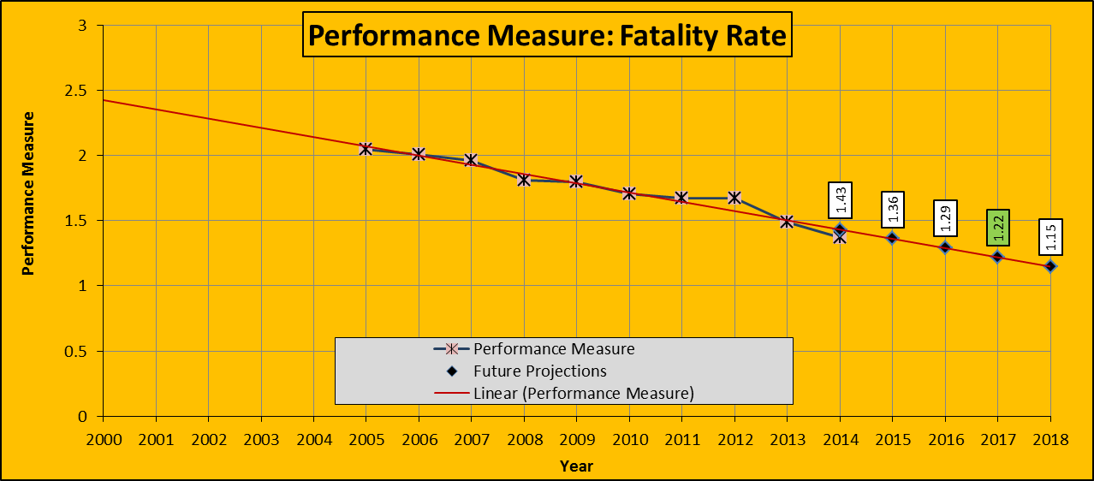

## Alternate Baseline – Fatality Rate





## Simple Average for 5 Years Actual Data – Fatality Rate

|  |  |  |  |  |  |  |
| --- | --- | --- | --- | --- | --- | --- |
| **Year** | **2011** | **2012** | **2013** | **2014** | **2015** | **Average** |
| **Number of Fatalities** | 1.67 | 1.67 | 1.49 | 1.37 | **1.52** | **1.54** |

## 5 Years Actual Data Trend– Fatality Rate

|  |  |  |  |  |  |  |  |  |
| --- | --- | --- | --- | --- | --- | --- | --- | --- |
| **Year** | **2012** | **2013** | **2014** | **2015** | **2016** | **Average** | **Simple Increase 2017** | **Trend Prediction 2017** |
| **Number of Fatalities** | 1.67 | 1.49 | 1.37 | **1.52** | **1.69** | **1.55** | **1.87** | **1.57** |

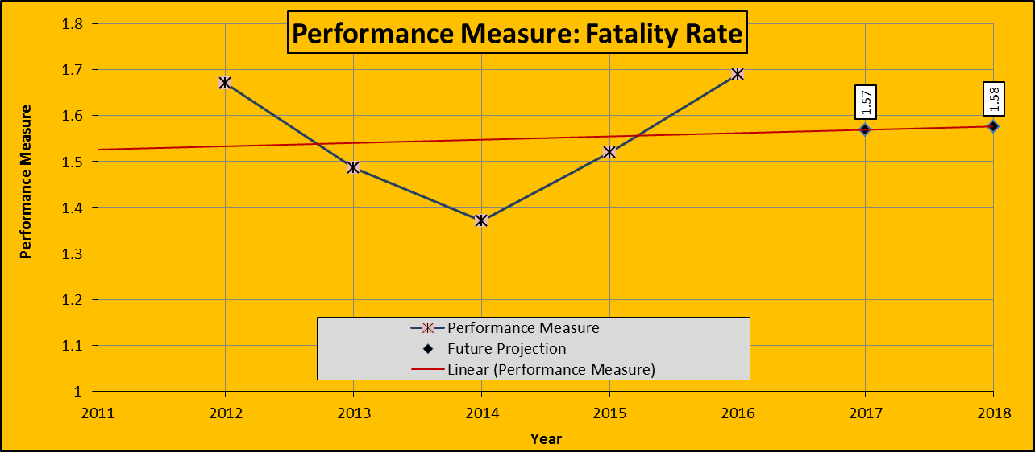

## Simple Average for 5-Year Rolling Averages – Fatality Rate

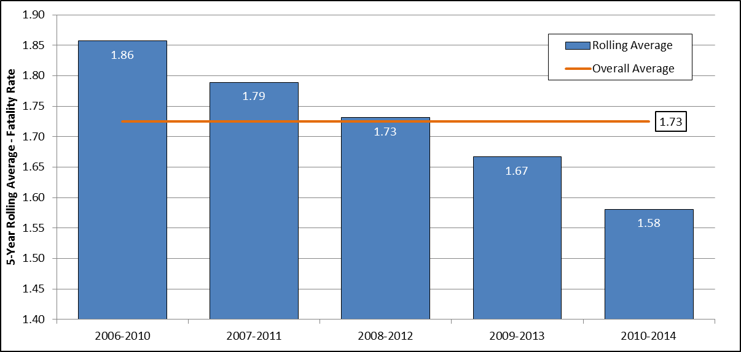

## Simple Average for 5-Year Rolling Averages (preliminary 2015 included) – Fatality Rate

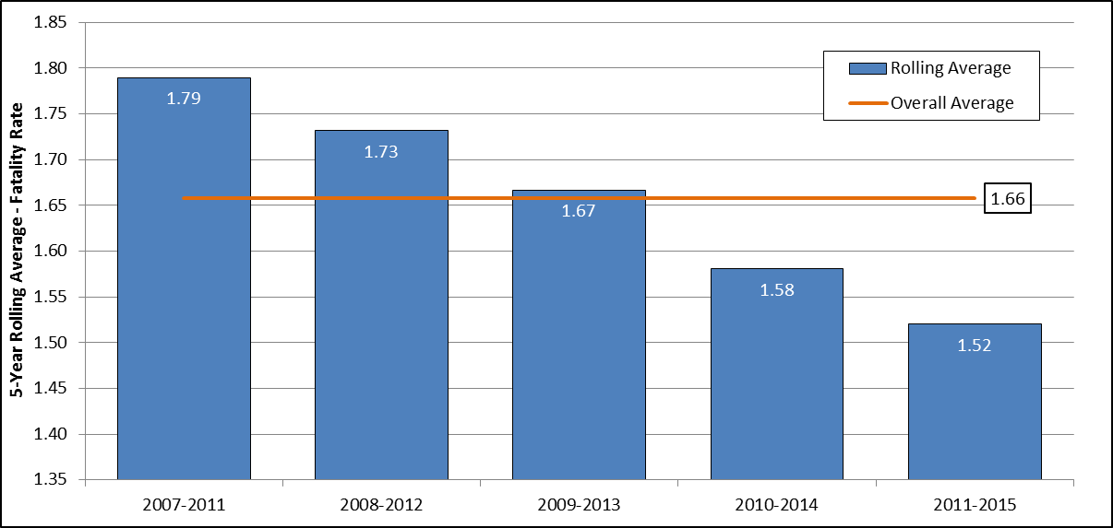

# SERIOUS INJURY

## 5-Year Rolling Average Trend – Serious Injury

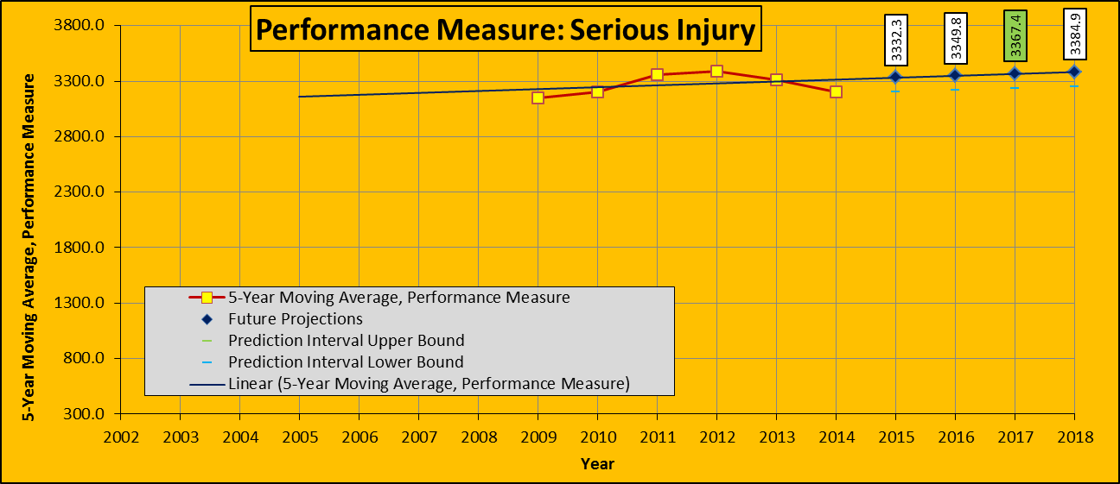

## 3-Year Rolling Average Trend – Serious Injury

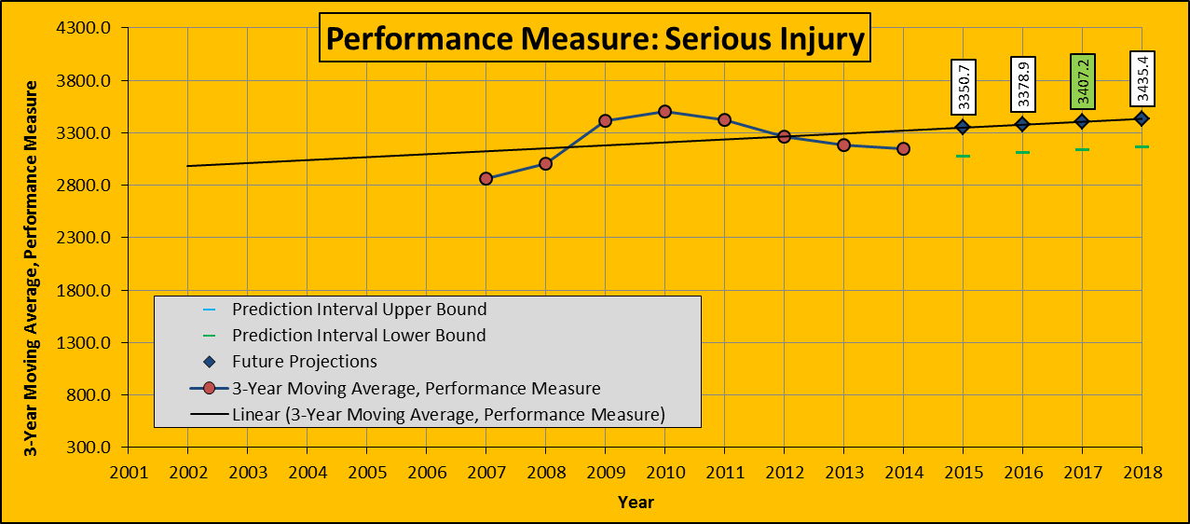

## 10 Years Actual Data Trend – Serious Injury

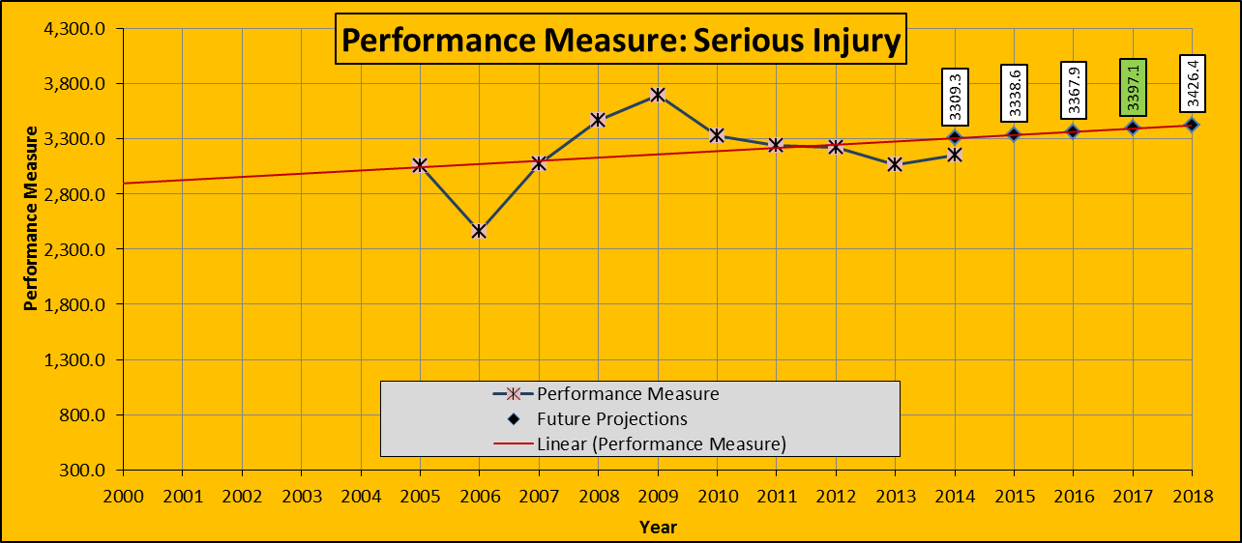

## Alternate Baseline – Serious Injury





## Simple Average for 5 Years Actual Data – Serious Injury

|  |  |  |  |  |  |  |
| --- | --- | --- | --- | --- | --- | --- |
| **Year** | **2011** | **2012** | **2013** | **2014** | **2015** | **Average** |
| **Number of Fatalities** | 3239 | 3226 | 3070 | 3154 | **3594** | **3257** |

## 5 Years Actual Data Trend– Serious Injury

|  |  |  |  |  |  |  |  |  |
| --- | --- | --- | --- | --- | --- | --- | --- | --- |
| **Year** | **2012** | **2013** | **2014** | **2015** | **2016** | **Average** | **Simple Increase 2017** | **Trend Prediction 2017** |
| **Number of Fatalities** | 3226 | 3070 | 3154 | **3594** | **4095** | **3428** | **4667** | **4107** |

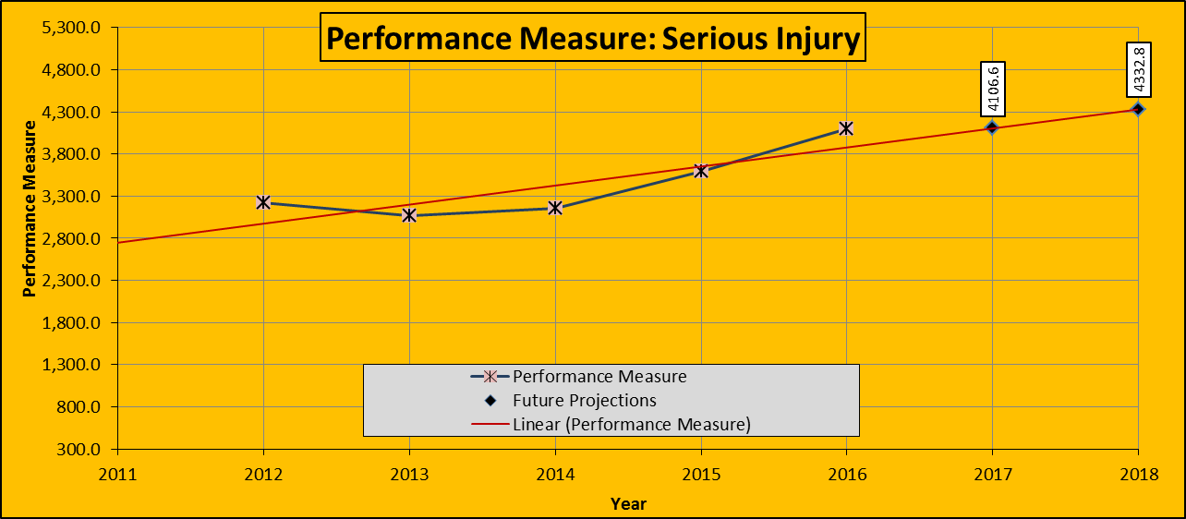

## Simple Average for 5-Year Rolling Averages – Serious Injury

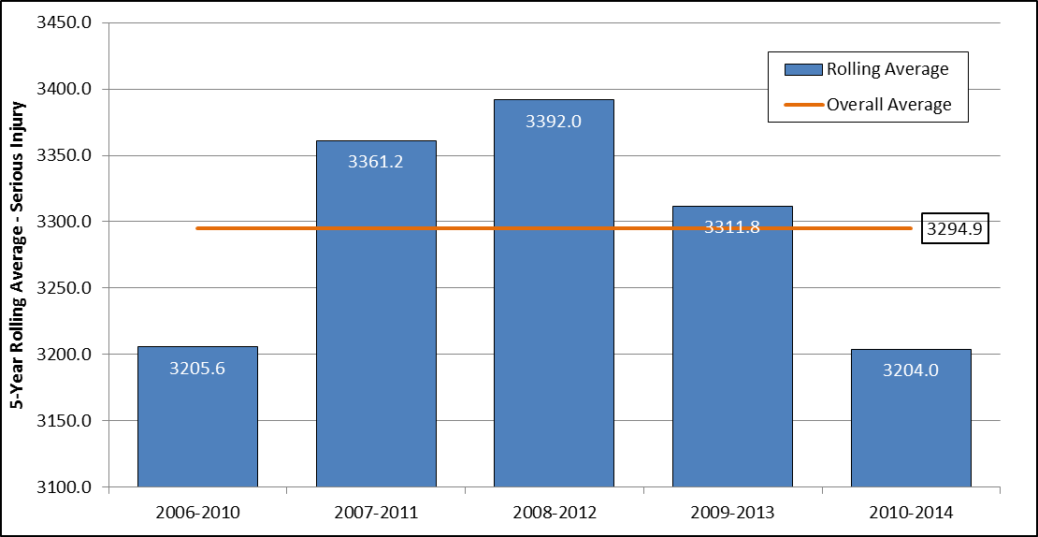

# SERIOUS INJURY RATE

## 5-Year Rolling Average Trend – Serious Injury Rate

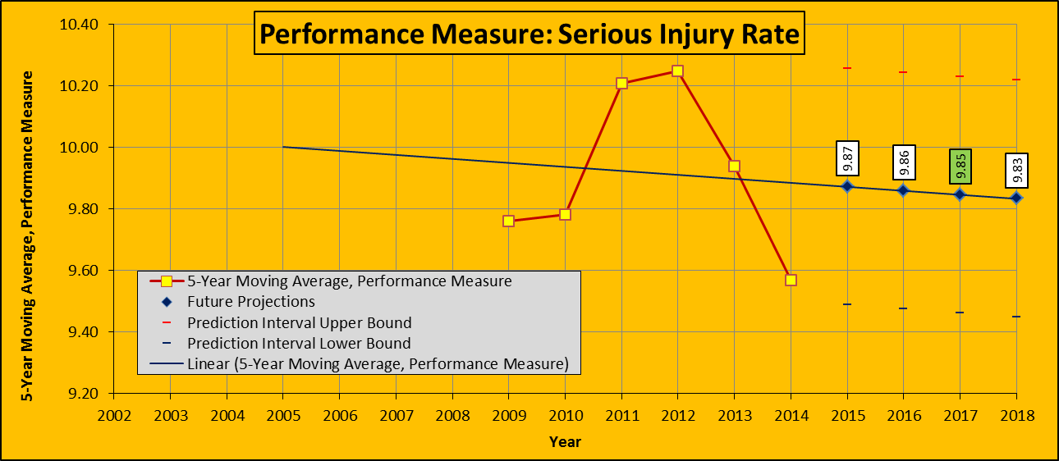

## 3-Year Rolling Average Trend – Serious Injury Rate

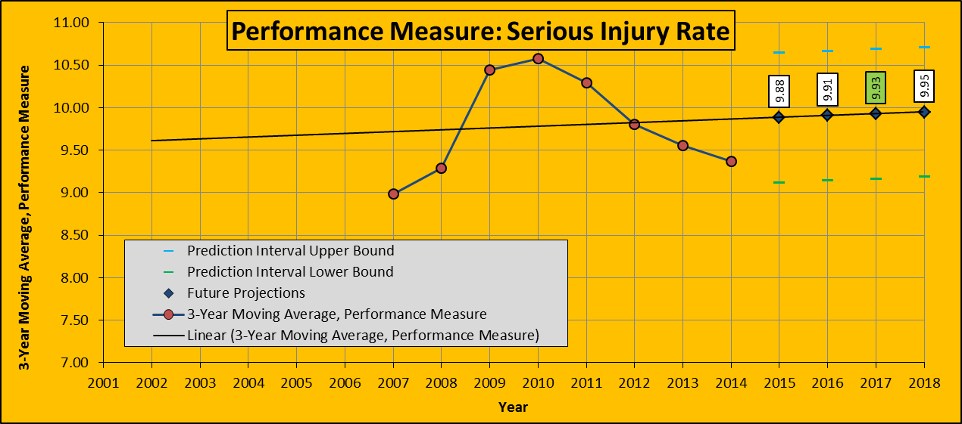

## 10 Years Actual Data Trend – Serious Injury Rate

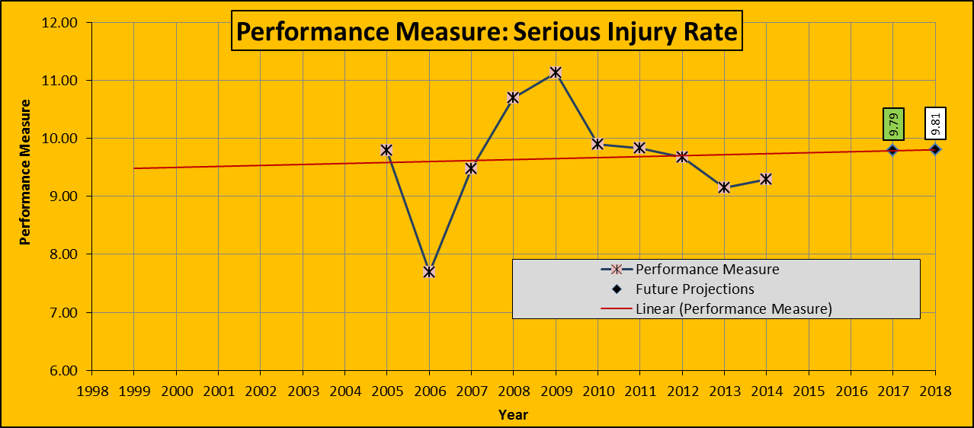

## Alternate Baseline – Serious Injury Rate





## Simple Average for 5 Years Actual Data – Serious Injury Rate

|  |  |  |  |  |  |  |
| --- | --- | --- | --- | --- | --- | --- |
| **Year** | **2011** | **2012** | **2013** | **2014** | **2015** | **Average** |
| **Number of Fatalities** | 9.83 | 9.67 | 9.15 | 9.29 | **10.31** | **9.65** |

## 5 Years Actual Data Trend– Serious Injury Rate

|  |  |  |  |  |  |  |  |  |
| --- | --- | --- | --- | --- | --- | --- | --- | --- |
| **Year** | **2012** | **2013** | **2014** | **2015** | **2016** | **Average** | **Simple Increase 2017** | **Trend Prediction 2017** |
| **Number of Fatalities** | 9.67 | 9.15 | 9.29 | **10.31** | **11.43** | **9.97** | **12.69** | **11.37** |

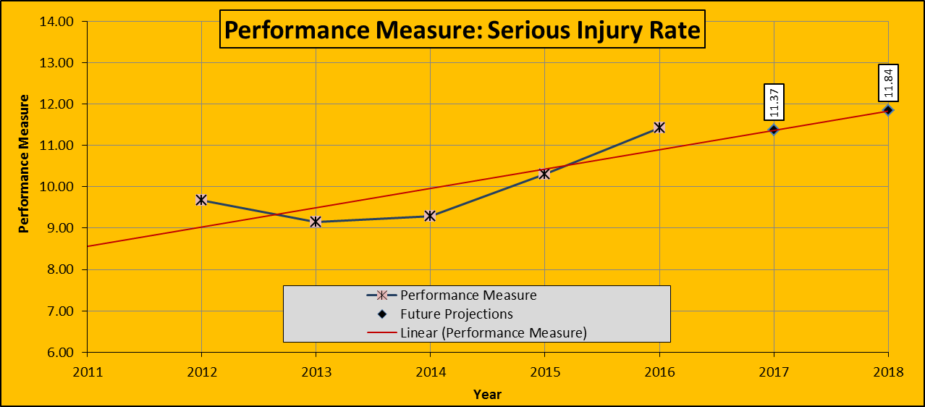

## Simple Average for 5-Year Rolling Averages – Serious Injury Rate

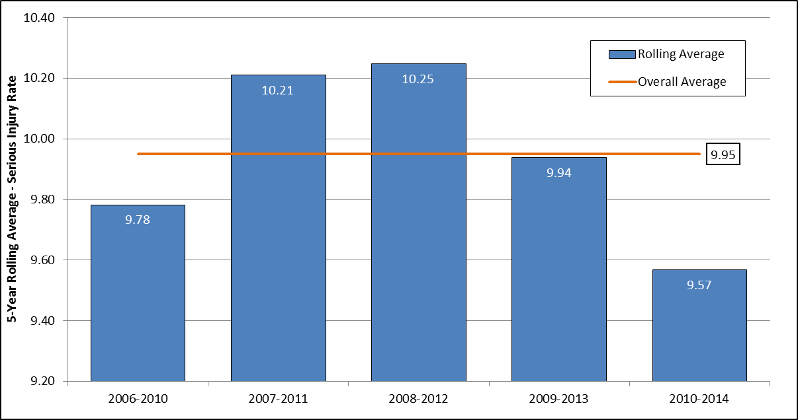

# Non-motorized Fatalities and Serious Injuries

## Simple Average for 5 Years Actual Data – Non-Motorized Fatalities and Serious Injuries

|  |  |  |  |  |  |  |
| --- | --- | --- | --- | --- | --- | --- |
| **Year** | **2010** | **2011** | **2012** | **2013** | **2014** | **Average** |
| **Number of Non-Motorized Fatalities and Serious Injuries** | 138 | 150 | 156 | 149 | 144 | **147** |

## 5 Years Actual Data Trend – Non-Motorized Fatalities and Serious Injuries

|  |  |  |  |  |  |  |  |
| --- | --- | --- | --- | --- | --- | --- | --- |
| **Year** | **2010** | **2011** | **2012** | **2013** | **2014** | **Average** | **Trend Prediction 2017** |
| **Number of Non-Motorized Fatalities and Serious Injuries** | 138 | 150 | 156 | 149 | 144 | **147** | **153** |

